UW Extension  
Certificate in C# Advanced Programming

# Creating Web Applications in C# Project

In this project you create a simple data driven website using Microsoft’s ASP.Net and a SQL Server database. You instructor has created this database for you, and your job will be to use this database to create the solution. Here is a video overview: <http://youtu.be/dWHfFL9vjRI>.

NOTE: For this 5 week version of the project, you do not have to host the project on the internet or have a peer review as mentioned in the video.

The new project database (called AdvWebDevProject) contains the tables shown in Figure 1. Your instructor will provide you with a SQL Script that creates these tables, as well all of the stored procedures required for the project.

### Figure1: The tables of the AdvWebDevProject database.

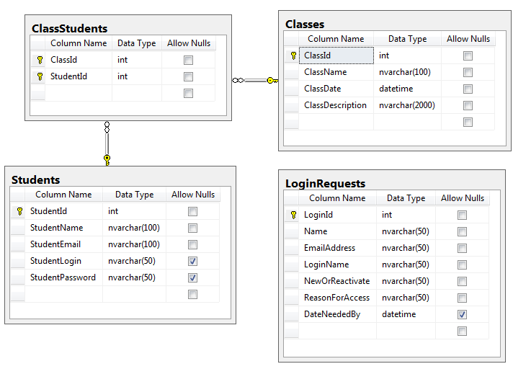

## The Web Site

Using the tables shown in Figure 1, you will create the set of web pages shown in Figure 2.

Figure 2: The project web pages 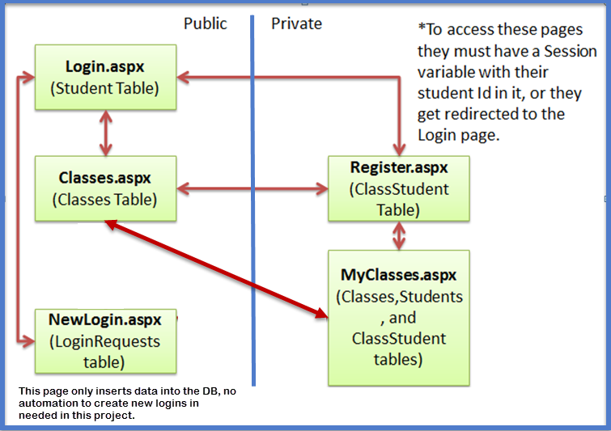

## ****Abstraction Layers****

The Presentation, Processing, and Data layers of your web application need to be separated using abstraction. So, all data processing code must be created in one or more classes and placed either in the App_Code folder or compiled into a .dll and added to the Bin folder. In addition, all of your transactional SQL code needs to be placed in stored procedures and not in your C# methods. Figure 3 shows the connections between the different layers of abstraction.

### Figure 3: The project’s abstraction layers.

### 

# ****Timeline****

The project contains 3 milestones. At each of these milestones a portion of the project is due. The milestones are:

#### Create the Classes page (Due by class 8)

This is semi completed via Homework03.

#### Create the Login and NewLogin pages (Due by class 9)

#### Complete the whole Website (Due by class 10)

For an example of what the project will look like see this one hosted here:

<http://northwesttech.org/ASPDemoSites/ClassRegistrationSite/>